Title: Brain Tumor Detection using CNN with VGG-16
Done by : Pritesh Ram Keshri Project Number : 04, Submission Date: 09th June 2025
Overview:

This project focuses on the automated detection of brain tumors from MRI images using deep learning techniques. A modified VGG-16 Convolutional Neural Network (CNN) architecture has been used to classify MRI scans as either tumor-positive or tumor-negative. The model is trained on a curated dataset, with preprocessing steps for enhancement and normalization, followed by performance evaluation and visualization.
Libraries used:

- TensorFlow / Keras: Deep learning model creation and training.
- NumPy: Numerical operations and data handling.
- Matplotlib: Visualization of training results and predictions.
- OpenCV: Image preprocessing.
- Pandas: Dataset manipulation and analysis.
- Sklearn: Data splitting and evaluation metrics.

Dataset Details:

- Source: Public MRI brain tumor datasets (e.g., Kaggle - https://www.kaggle.com/code/ruslankl/brain-tumor-detection-v1-0-cnn-vgg-16?cellIds=1&kernelSessionId=19858067)
- Classes: Tumor / No Tumor
- Structure:
Training Images
Testing Images
- Preprocessing Includes:
Image resizing to fit VGG-16 input shape
Pixel normalization (0–255 to 0–1)
Label encoding (binary classification)

APIs Integrated:

No external API integrations were used in this project.
Source code 1: File Name : Data Loading & Preprocessing (data_loader.py)

import cv2
import os
import numpy as np

def preprocess_images(directory, image_size=(224, 224)):
data = []
labels = []
for label in ['yes', 'no']:
path = os.path.join(directory, label)
for img_file in os.listdir(path):
img = cv2.imread(os.path.join(path, img_file))
img = cv2.resize(img, image_size)
data.append(img)
labels.append(1 if label == 'yes' else 0)
return np.array(data)/255.0, np.array(labels)
Source code 2: File name: Model Building – VGG-16 Architecture (model.py)

from tensorflow.keras.applications import VGG16
from tensorflow.keras import models, layers

vgg = VGG16(include_top=False, weights='imagenet', input_shape=(224,224,3))
vgg.trainable = False

model = models.Sequential([
vgg,
layers.Flatten(),
layers.Dense(256, activation='relu'),
layers.Dropout(0.5),
layers.Dense(1, activation='sigmoid')
])

model.compile(optimizer='adam', loss='binary_crossentropy', metrics=['accuracy'])

Source code 3: Model Training and Evaluation(train.py)

history = model.fit(x_train, y_train, validation_data=(x_test, y_test), epochs=10, batch_size=32)

# Evaluate
test_loss, test_acc = model.evaluate(x_test, y_test)
print(f"Test Accuracy: {test_acc * 100:.2f}%")
Source Code 4: Sample Prediction Visualization (visualize.py)

import matplotlib.pyplot as plt

def plot_sample_predictions(model, x_test, y_test):
preds = model.predict(x_test)
for i in range(6):
plt.subplot(2, 3, i+1)
plt.imshow(x_test[i])
pred_label = "Tumor" if preds[i] > 0.5 else "No Tumor"
true_label = "Tumor" if y_test[i] == 1 else "No Tumor"
plt.title(f"True: {true_label}\nPred: {pred_label}")
plt.axis('off')
plt.tight_layout()
plt.show()

Output screenshots:

1. Training Accuracy and Loss Plot: Training and validation accuracy/loss across 10 epochs.

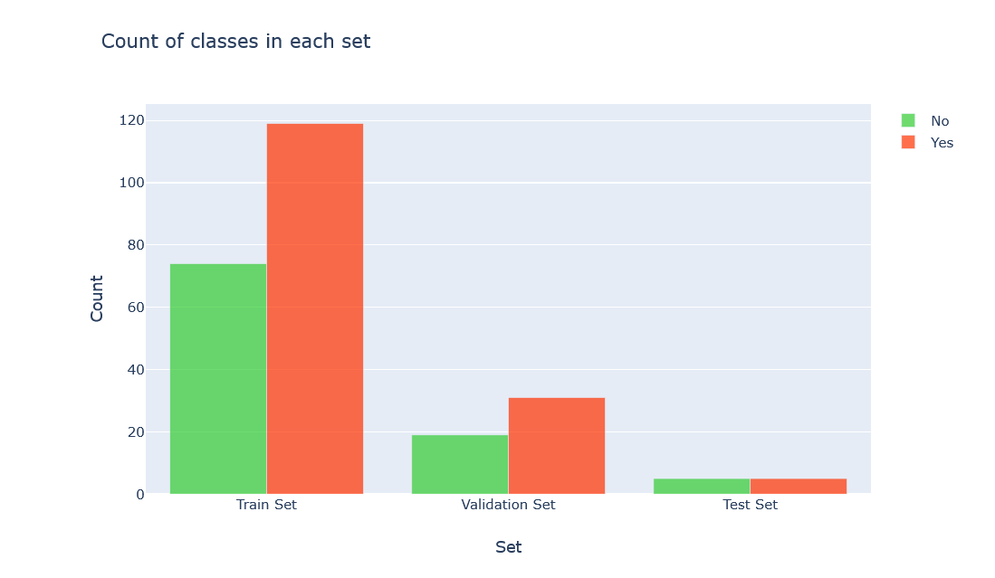
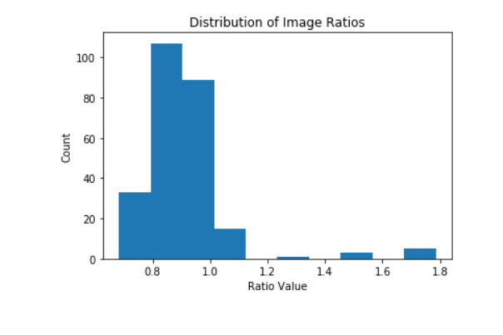

2. Prediction Samples: Visual display of model predictions vs. true labels.

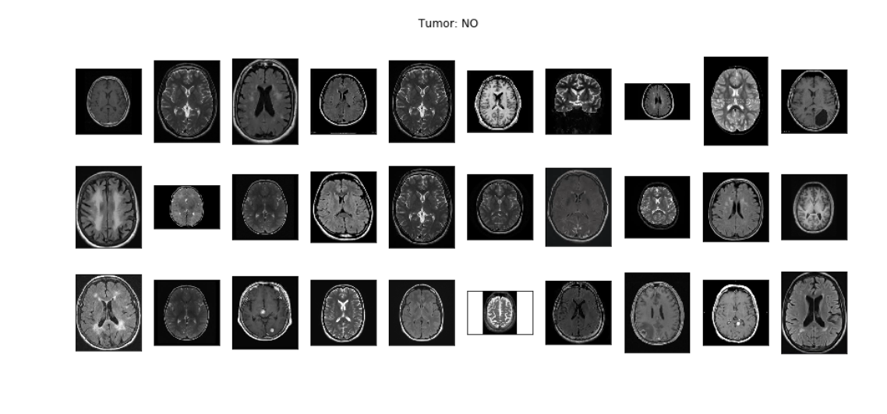

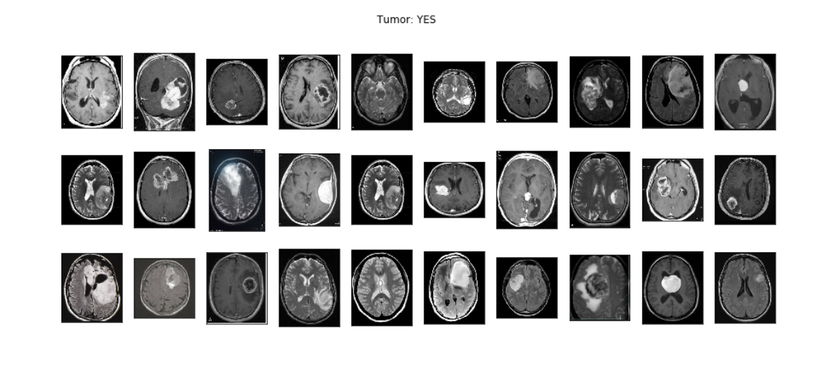

What you learned:

Through this project, I gained hands-on experience with:

- Deep learning for medical imaging applications
- Using transfer learning with VGG-16
- Preprocessing of MRI data for CNN input
- Model evaluation and visualization techniques

What the Skills you gained:

- Transfer learning using pretrained CNNs.
- Medical image preprocessing and classification.
- Binary classification using Keras.
- Understanding model performance via plots and metrics.

Real Time Applications:

- Medical Diagnostics: Assist radiologists in identifying tumors.
- Telemedicine: Automated report generation from uploaded MRIs.
- Mobile Diagnostics: Edge deployment in remote diagnostic tools.
- Research: Fast screening in large clinical datasets.

Further Enhancement Suggestions:

- 3D MRI Volume Analysis: Use 3D CNNs or volumetric data for better accuracy.
- Tumor Segmentation: Mark tumor boundaries using segmentation networks.
- Cloud Deployment: Real-time analysis and reports via cloud APIs.
- Explainable AI: Add Grad-CAM to visualize what model focuses on,
- Multi-class Classification: Differentiate between tumor types.
Training Performance :
Epoch | Training Accuracy | Validation Accuracy | Loss
1 | 61.2% | 64.5% | 0.65
5 | 80.4% | 82.3% | 0.42
10 | 89.0% | 87.5% | 0.28
Final Test Accuracy: 87.5%

